**IPv4 Header**

* IPv4 header guides packet delivery.
* It contains essential packet information.
* Fields are binary numbers for Layer 3 processing.
* It ensures packets reach their next hop.
* 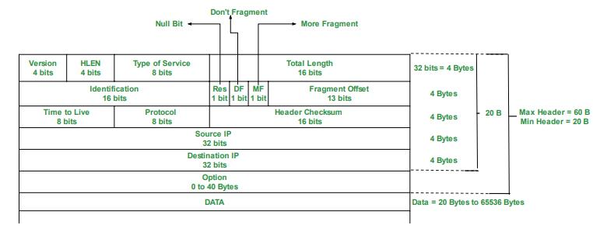It is a key part of the IPv4 network layer protocol.

**- Version (4 bits):** indicates the IP protocol version. There are only two versions of Ip in used: IPv4 =4 (0100) and IPv6 = 6 (0110) but the IPv4 is default in this case.

- **Internet Header Length (IHL) (4 bits):**

+ The final field of the IPv4 header (Options) is variable in length, so this field is necessary to indicate the total length of the header.

+ Identififes the length of the header in 4-byte increments.

+ Minimum value is 5 (=20 bytes).

+ Maximum value is 15 (15 x 4-bytes = 60 bytes)

+ Minimum IPv4 Header length = 20 bytes

**- Types of Service (8 bits):**

+ DSCP (Differentiated Services Code Point – 6 bits):

* Used for QoS (Quality of Service)

* Used to prioritize delay-sensitive data (streaming voice, video, etc,..)

+ ECN (Explicit Congestion Notification – 2bits):

* Provides end-to-end (between two endpoints) notification of network congestion without dropping packets.

**- Total Length field (16 bits):**

+ Indicates the total length of the packet (L3 header + L4 segment)

+ Measured in bytes (not 4-byte increments like Ihl)

+ Minimum value of 20 (=IPv4 header with no encapsulated data)

+ Maximum value of 65,535 (maximum 16-bit value).

**- Identification filed (16 bits):**

+ The MTU is usually 1500 bytes

+ Maximum size of an Ethernet frame…

+ Fragments are reassembled by the receiving host

**- Flags Field (3 bits):**

+ Used to control/identify fragments

+ Bit 0: Reserved, always set to 0

+ Bit 1: Don’t Fragment (DF bit), used to indicate a packet that should not be fragmented.

+ Bit 2: More Fragments (MF bit), set to 1 if there are more fragments in the packet, set to 0 for the last fragment.

**- Fragment Offset field (13 bits):**

+ Used to indicate the position of the fragment within the original, unfragmented IP packet.

+ Allows fragmented packets to be reassembled even if the fragments arrive out of order.

**- Time to live field (8 bits):**

+ A router will drop a packet with a TTL of 0

+ Used to prevent infinite loops

+ Originally designed to indicate the packet’s maximum lifetime in seconds

+ In practice, indicates a ‘hop count’: each time the packet arrives at a router, the router decreases the TTL by 1

+ Recommended default TTL is 64

**- Protocol field (8 bits):**

+ Indicates the protocol of the encapsulated L4PDU

+ Value of 6: TCP

+ Value of 17: UDP

+ Value of 1: ICMP

+ Value of 89: OSPF (dynamic routing protocol)

**- Header Checksum field (16 bits):**

+ A calculated checksum used to check for errors in the IPv4 header.

+ When a router receives a packet, it calculates the checksum of the header ad compares it to the one in this field of the header.

+ If they do not match, the router drops the packet

+ IP relies on the encapsulated protocol to detect errors in the encapsulated data.

+ Both TCP and UDP have their own checksum fileds to detect errors in the encapsulated data.

**- Length: 32 bits (each):**

+ Source IP Address = IPv4 address of the sender of the packet

+ Destination IP Address = IPv4 address of the intended receiver of the packet.

- Optiond fields (Length: 0 – 320 bits):

+ Rarely used

+ if the IHL field is greater than 5, it means that Options are present.it means that Options are present.